Parking policy for Aurangabad City
for
Aurangabad Municipal Corporation (AMC)

Date of Publication: 28th July 2022

Municipal Commissioner
&
Administrator,
Aurangabad Municipal Corporation
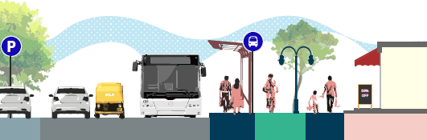

Message from the Municipal Commissioner

Dear friends,

Transport systems influence a major part of our everyday lives. Aurangabad has embarked on multiple initiatives in the past to provide a safe, efficient, and inclusive transport system one of which is introducing Majhi Smart Bus in the city.

It is our duty to make our streets safe for the well-being of our citizens, to empower local businesses, and for the safety, live ability, and resilience of the city. In Aurangabad, journeys take place through our network of streets with different modes of transport. Every journey needs to end and at the end of the journey there is a space required for parking the chosen mode of transport. Which states that parking space is a necessity for every journey or trip that takes place in the city. The growing need for parking is a major problem faced by most Indian cities and Aurangabad is no exception. The growth rate of two wheelers and four wheelers in Aurangabad city is high. As a result of this, various problems have arisen in the city such as increasing vehicular congestion on the roads, adverse environment for walking and cycling, roads becoming wider in terms of accommodating more vehicles. In view of the future growth, needs and sustainable development of the city, the Aurangabad Municipal Corporation have formulated a progressive parking policy for the city. This is an important step towards the sustainable development of the city.

The vision of having safe, sustainable and inclusive streets will only be possible with participation from local communities and diverse stakeholders. We thank you for your support in this journey. I am confident that together, we will use this opportunity to make the vision a reality by implementing this Parking Policy in Aurangabad city.

Municipal Commissioner
&
Administrator,
Aurangabad Municipal Corporation

Table of Contents
INDEX
1. Introduction 5
2. Definitions 6
3. Principles for parking management & regulation 7
4. Determining Parking rates 9
5. Area Parking Plan (APP) 12
6. Parking policy guidelines for transport vehicle parking 15
7. Institutional structure 18
8. Implementation of parking policy 21
9. Regulating Off-street parking 26
10. Violations and Compliance 29
Annexures 31
Aurangabad city- Current Parking issues and future crisis 32
B. Aurangabad city data analysis 35
Population data 35
Aurangabad city data- Vehicle population and projection. 35
Vehicle density 36
Comparative analysis of population and Vehicle density 36
Vehicle ownership 36
Equivalent car space unit (ECS) 36
Parking space requirement 37
Parking space requirement for type of car parking facility 37
Cost investment for building off street car parking facility 38
C. Case Studies Case study 1 39
Case study 2 39
D. Surveys for Area Parking Plan (APP) 40
Table A – Parking Inventory: Morning Peak 41
Table C – Parking Inventory: Night 42
Table E – Determining Available Road Length for Parking 42
E.Pilot Studies based on APP Survey 44
2. USMANPURA - KRANTI CHOWK 47
3. TV CENTRE 49
4. NIRALA BAZAAR - AURANGPURA 52
5. PUNDLIK NAGAR - GAJANAN MANDIR 54
F.Proposed Parking Fees Proposed Peak hour parking fees 56
Proposed Long term parking fees 56
Projected Revenue collection from Pay and park: 57

Introduction

Aurangabad Municipal Corporation, in association with relevant government agencies and partner agencies, aims to ensure that people of all age groups, gender, and socio- economic backgrounds to have access to a good mobility.

Personal motor vehicles in the city of Aurangabad are growing at around 10% per annum while the population is not growing more than 3%. Considering mobility by personal motor vehicles as inevitable, in the absence of efficient and comfortable sustainable modes of transport like walking, cycling, and public transport (henceforth referred to as sustainable modes of transport), AMC will focus on sustainable modes, which require significantly less road space compared to private vehicles and do not create environmental pollution. AMC will expand the network of public transport, improve and increase city bus services, develop a network of safe, adequate, and accessible footpaths and cycle tracks, and improve intermodal integration to meet the growing transportation needs of the city.

The need for parking spaces is growing at 25-30% per annum, as every vehicle needs 2-3 parking spaces in a city. Personal motor vehicles daily run approximately only for two hours but are parked for 22 hours. AMC has realised that the provision of parking space for personal motor vehicles has become a very challenging issue as road space is an expensive and scarce resource. In order to reduce traffic congestion and vehicular pollution caused due to the growing number of personal motor vehicles and unrestricted road space taken up for their parking, AMC proposes to adopt and implement appropriate policies that discourage the use of personal motor vehicles.

Managing and regulating parking is a key aspect of this approach to ensure available road space is allocated for efficient pedestrian and vehicular traffic movement, defined regulated parking and hawking, as well as for socialising since streets are the most important public spaces in our cities. This document presents AMC’s parking policy.

Definitions

The following definitions shall apply for the purpose of this policy.

Personal motor vehicles:

Motorized vehicles that run on fossil fuel or electricity, that may be owned by individuals, companies, or public agencies, but are used by a single person or his/her family (as against commercial services such as taxis, auto rickshaws, or buses that are available to public on payment of a user fee).

On street parking:

Parking at a location on a public right-of-way, either formal or informal.

Off street parking:

Parking at a location not on a public right-of-way, such as an open or covered plot, or on any level of a built structure, whether or not for a fee.

Peak-period:

A period of time in a day during which parking occupancy is greater than the mean parking occupancy in a day. Typically, peak-period ranges from one to three hours.

ECS:

The space required to park one car is equivalent car space unit.

Occupancy:

Percentage of occupied number of ECS of parking at any given point in time. Average occupancy is the average of occupancy in any given period of time (typically stated for a peak period).

Principles for parking management & regulation

Parking is a commodity, not a public good. In making decisions relating to parking management and regulation in the city, AMC will adhere to the following principles.

Manage and enforce on-street parking.

Free and haphazard on street parking has aggravated traffic congestion and pollution on roads. Free availability parking results into, very high growth of personal motor vehicles, also due to poor enforcement, it is observed that most off-street parking available to users of personal motor vehicles, it is often underutilised. Free on-street parking has incentivised several private property owners of commercial and residential properties to violate parking requirements and also convert in- house parking space into other uses. Introduction of pricing of on-street parking shall serve as an encouragement for these properties to reinstate the mandatory parking requirements. AMC will ensure that on-street parking shall be managed and enforced effectively.

Prioritise sustainable modes of transport.

To improve sustainable mobility for common people, it is important to strengthen public transport, intermediate public transport network and high-quality footpaths and cycle tracks for last mile connectivity. AMC will give priority to high quality facilities for sustainable modes of transport over parking of private vehicles.

Parking revenue for sustainable modes of transport.

AMC will adopt an appropriate mechanism to ensure that all parking revenue generated from parking fee shall be deposited in a dedicated Parking Fund Account created by the municipal corporation. AMC shall give priority to sustainable modes of transport in its spending to achieve 10 to 20 % shift of personal motor vehicles to sustainable alternatives. This shall make significant difference to smoother travel and remove need for off street parking infrastructure and thereby the cost

Regulated Parking supply

Parking supply, including off street and on street parking, should be limited to avoid overwhelming the road network in the city. AMC will regulate the total quantum of on street parking and off-street parking available in the city.

AMC will desire to change building regulations, for private off-street parking to have maximum parking permissible of 1 ECS for 100 sqm of built up area which is not free of FSI, to limit number of vehicles to reduce carbon footprint, congestion and also make real estate more affordable to common people.

No subsidy to parking.

AMC will not subsidies either on-street or off-street parking (including multi-level parking) for personal motor vehicles, implicitly or explicitly.

AMC shall discourage new off-street parking facilities as it is an unsustainable and economically unviable solution. They can be considered only if parking shortage persists after effective management and enforcement of on street parking in the surrounding area.

Public Land used for private parking shall be discouraged and if given shall be on market price. Multilevel /underground off street parking should not be treated as infrastructure but it is a facility for private use. The private operator shall have to charge adequate fees for its economic viability.

AMC will ensure significantly higher on street parking fees are than the off-street facility, so that people will pay adequate parking fees to the private operator. With effective management, and enforcement of on-street parking, private development of off-street parking facilities will become necessary and eventually after bearing the full cost of land, construction, maintenance, and operations — should become viable business that can recover its investment directly from parking users without any form of cross subsidy.

Determining Parking rates

Parking fee

Parking fees will be reviewed regularly based on occupancy data. Fees based on both Demand and supply. Higher the demand higher the fees. Lower the demand lower the fees.

Duration of parking

Parking fee shall be in proportion to the time parked. Discounts for long-term parking shall be discouraged. The fees should increase per hour as you park longer

Cost of parking

Parking fee for Equivalent Car Space shall be based on rental value of the land. (2% of the ownership value)

No of parking hours per year

3000 Hours /year (300 working days/year x 10 hour /day)

Parking occupancy levels

High occupancy levels will cause fee increases, low occupancy rates will cause fee decreases, and occupancies within the target range will result on no fee adjustment.

Parking occupancy consistently greater than 60% for several peak parking hours on any given Lot, will initiate charging parking fees. If occupancy is consistently less than 60% on any given lot, even in the peak parking hours, then AMC may choose not to levy any parking fee.

Parking occupancy consistently greater than 90% for several peak parking hours on any given Lot, will cause increase in parking fees.

Such an increase is aimed to reduce the demand for such high-demand spots and ensure that people who have the highest willingness to pay for such spots are able to find vacant spots, when needed. (Min 10% vacant spots are desirable).

If the occupancy during peak hours is consistently below 70%, the rates shall be revised marginally downwards to bring occupancy between 70 to 90%.

Location of the parking lot

As a result of the occupancy-based adjustments mentioned above, AMC expects that parking will come to be priced higher in areas of high demand. AMC also expects that on-street parking fees will come to be higher than fees for off-street public parking.

Cover full cost of parking.

Off-street parking shall not be built by the city if the expected fees will not cover the full cost of creating and operating the facility. It should not be cross subsidised through other means.

Time of the day, day of the week.

To achieve the desired occupancy range and ensure some parking vacancies (10%) during peak periods, the price of parking during peak parking periods may need to be higher than non-peak parking hours

Size of the vehicle

The parking charges should be based on the size of the vehicles as smaller vehicles occupies lesser space, Large cars and SUV occupy more space thus more fees.

Day parking pass

Day parking during traffic hours impacts traffic. In the mixed land use high demand area parking rates for day parking pass shall be calculated on the basis of daily 12- hour parking charges multiplied by minimum of 10 days for monthly pass. Passes allotted not more than 40% of the road stretch based on auction.

Night parking pass

Night parking has less conflict with mobility. In Residential areas parking rates for night parking pass shall be calculated as 30% or lower of day parking monthly pass. Quarterly and annual Passes shall be made available.

No of Passes allotted must be lesser (at least 10%), than the no of available parking spaces, to ensure availability of parking but no exclusively defined space for pass holder.

Graded approach

To implement parking policy graded approach will be effective with stakeholder engagement. Initiate policy implementation only at very high demand areas during peak hrs. Depending on the occupancy levels pay and park lots can extend duration to full day and later night parking.

Also initiate with lower fees and increase gradually. Periodic revisions based on demand and occupancy levels.

Prices for any publicly-owned and publicly-accessible off-street parking shall follow the same pricing principles of pricing as on-street parking. This approach results in a higher price for more desirable locations and periods of time during a day, and lower price for less desirable locations, such as off-street multi-level parking.

This approach would ensure efficient use of both on-street parking and off-street parking facilities, as well as free up road space for other uses such as creation of footpaths, cycle tracks, bus rapid transit, and public spaces.

  - Periodic audits - Third-party periodic audits conducted to estimate actual occupancy levels.

Parking fee exemptions

The following types of vehicles may be exempt from parking fees when parked in designated slots during certain periods.

    - Bicycles parking shall be free of charge at all times.
    - Parking fee shall not apply on passenger auto rickshaws and taxis when parked in designated lots meant for their parking.

    - Parking fee shall not apply on Public and Private Bus -as a sustainable mode of transport when parked in designated lots meant for their parking.

    - Parking fee shall not apply on Transport vehicles when parked in designated lots meant for their parking. Parking fee shall not apply if they occupy a paid car parking lot during Loading/unloading activity for no longer than 15 minutes during off- peak parking hours. However, parking fee shall apply on such vehicles during peak parking hours.

    - Considering the growing vehicle density and scarcity of road space, AMC, after regulating the total quantum of on street parking and public off street parking available in the city, shall charge subsidised parking fees to private buses and private intermediate public transport in future.

Area Parking Plan (APP)

The objective of Area parking plan (APP) is to identify possible parking space for effective demand management.

To create an area parking plan, high demand parking location will be identified for pay and park lots. All roads directly connecting to the Pay and Park lots up to 500m will come under compliance zone.

APP should be based on the proposed guidelines. Pay and park lots will be designated based on the occupancy levels. While preparing APP it is important not to compromise efficient traffic circulation, therefore, mapping right of way (ROW), road carriage width, footpaths on either side, median, traffic flow and volumes, traffic density and land use is essential to understand feasibility of parking. It is important to undertake parking inventory during peak hours to understand existing parking saturation level for effective planning and management. Identifying “No parking zones” in consultation with traffic police and other stakeholders is necessary. This will help in demarcating available road lengths for parking to propose Pay and park lots with possible number of ECS.

Note: While preparing APP, the actual parking space allocation may be determined based on site condition and stakeholder consultations.

Revision of Area parking plan

- Task Forces shall periodically (every 2-3 years) review the APP for changes in parking demand with change in land use.

- The Area Parking Plans shall be adopted by the Development Plan and Comprehensive Mobility plan (CMP) for Aurangabad. The APPs shall also be vetted for revision once in 5 years and along with the revision of the CMP for the city.

On street Pay and Park lots

AMC will undertake on street parking management with regulated priced parking, as this is the most effective demand management strategy to control rapidly growing private vehicles.

Short term parking - is mainly observed near commercial complexes, shops & establishments, markets, institutions, corporates, administrative buildings, clubs, hospitals, visitors in residential areas. During peak hours haphazard parking adversely impacts vehicular traffic flow and pedestrian safety and comfort.

Long term parking - is observed in commercial, business and mixed land use areas by the shop owners, office goers and also residents during the day time for more than 12 hrs to 24hrs. This leads to permanent blocking of road space leading to traffic congestion, pollution and inconvenience to pedestrians. In the residential areas’ cars are parked on public roads in the night for long term.

Guidelines for “Pay and Park lots”

On high volume traffic and very narrow roads, on street parking impacts mobility, thus to be regulated with effective on street management. Pay and park shall be initiated, when parking occupancy is consistently greater than 60% for several peak parking hours on any given Lot.

In old city or commercial land use areas where both pedestrian and vehicular volumes are high, if ROW is less than 15m,

    - Encourage one-way traffic circulation, so that there is enough space for pedestrians to walk and shop.

    - Encourage pedestrian only street during peak hours where footfalls are very high.

    - Discourage parking if traffic density is high with restricted parking only for residents and shop keepers.

    - Discourage four-wheeler parking on narrow roads.
    - Traffic calming measures on very narrow roads without raised footpaths.
    - Discourage long term on street parking with higher fees

Guidelines for No-Parking Areas
- High-density mobility corridors, (arterial or major road) that experiences very high traffic volumes

- Narrow streets with very high pedestrian activity

- Within 10m of bus stops on either side.

- Within 5 m of rickshaw stands, and designated pedestrian crossings, intersections with ROW less than 18m.

- Within 15 m of intersections with ROW greater than or equal to 18 m.

- Within 50 m of entrances to bus terminals, railway stations

- Within 50 m of entrance to school on either side.

- Around off-street facility, up to a distance of 500m

- A traffic bottleneck identified by the Traffic Police.

- On footpaths, cycle tracks, pedestrian crossings and pedestrian refuge islands.

- Excess right-of-way due to irregular alignment of plot to be used for pedestrian or vending area and not for parking.

- At the entry of Hospitals, Fire stations, Electric sub-station etc.

- “No Parking” signage board must have fine value for the offences mentioned.

- In the absence of sign board and road signage, parking shall not be considered ill legal and shall not be liable for fines

- On-street parking spaces should be designed as per minimum requirements of IRC: SP:12- 2015 to the extent possible. The design should minimize conflict between parking, walking, cycling and hawking

Guidelines for allocation of road space for parking.
- Priority to 2-Wheeler parking over 4-Wheeler parking

- At least 10 % of parking spaces are available during peak hours to reduce searching traffic

- The preferred parking orientation in all on street Parking locations, is parallel for cars, LCVs, rickshaws, trucks, and buses; and perpendicular for two- wheelers and cycles.

- A minimum width of 2m to 2.5m is required to accommodate Cars, SUVs, Taxis, LCVs, Auto rickshaws.

- A width up to 3m is required for parking of HCVs, trucks and buses.

- In the design of streets for new or redeveloped streets, space for on-street parking shall be provided only after providing space for pedestrian footpaths minimum clear width of 1.5 m (without any obstructions) plus 0.5 m buffer next to compound walls and 1.0 m buffer next to commercial uses, cycle tracks (minimum clear width of 2 m) if required, bus stops and rickshaw stands, cycle stands, vending areas, and street trees.

- Promote and accommodate parking for bus bays, auto rickshaws stand, bicycles and other shared mobility transit to encourage sustainable mobility. Space for loading/un-loading and pick-up/drop-off, should also be considered.

- Dedicated bicycle parking shall be provided at regular intervals, and bicycles can be parked in any Parking Areas designated for two-wheelers.

- Parking spaces allocated to differently abled persons should be located closer to footpath ramps, elevators or access to establishments

Parking policy guidelines for transport vehicle parking

  - Parking of freight / Transport vehicles
  - Parking of Intercity/interstate buses
  - Parking of construction vehicles
  - Parking provisions for school transport

Parking of freight / Transport vehicles (HCVs, ICVs, MCVs and LCVs)

Freight related movement in cities is closely linked to location of wholesale markets, type of produce/item, existing distribution system etc. In order to improve freight related parking issues, the following short term and long-term proposals are suggested.

Short Term Strategies:

    - Freight vehicles (HCVs) may not be allowed to park on-street or carry out loading/unloading activities on-street during peak hours of the day in very congested areas.

    - Smaller freight vehicles (ICVs, LCVs and MCVs) carrying essential commodities like water and medicines may be exempted from the above restrictions.

    - A fine shall be levied if the freight vehicle that violate parking regulations and found parking within the public right of way in highly congested areas specifically identified.

Long Term Strategies:

Truck terminals and warehousing facilities shall be set up in city periphery in all major directions for heavy vehicles/trucks (HCVs or ICVs). These terminals should act as transfer hubs for goods to be transferred to smaller freight vehicles such as LCVs/MCVs for distribution within city limits.

Parking of Intercity/interstate buses:

A significant interstate and intercity travel demand are met by private and state- owned buses. Presently, these buses are allowed to ferry passengers to the interiors of the city and have multiple pick-up and drop off points (which includes waiting and halting) and results sometime in traffic congestion.

Short term Strategies:

Pick up and drop off of passengers by public buses and other private operators are permitted at authorised stops as per the route map approved by RTO, with proper necessary infrastructure like stand with waiting facility at least on high intensity stands and route maps.

Parking of public buses and privately-operated buses is permitted within the civic agency limits; however, such parking shall be outside the public right of way.

A fine shall be levied on all operators including public buses, that violate parking regulations, and found parking within the public right of way or other than authorised stops as per the route map approved by RTO for pick up and drop off of passengers in highly congested areas specifically identified.

Long term Strategies:

Strategic locations should be identified by the Transport Department for setting up of bus terminals and depots for state run and private intercity and interstate services. These should preferably be located near each other (or share the facility) and near cross roads of major highways entering the city and peripheral ring road alignment, to allow for dispersion of traffic from these terminals along the peripheral roads, thereby reducing the need for all traffic to enter the congested city core before dispersing.

These terminals should be well integrated with Public smart city bus services, IPT services, IT enabled taxi/ auto facility and other feasible last mile connectivity services to ensure passengers are not significantly burdened by the need to transfer.

Parking of construction vehicles:
    - Construction vehicles include HCV/LCV ferrying materials or any other vehicles aiding construction work, there is no restriction on carrying out construction activities if these construction vehicles are parked outside the public right of way in highly congested areas.

    - Construction vehicles that violate parking regulations, and found parking within the public right of way in highly congested areas specifically identified, shall be clamped and released on appropriate fine.

Parking provisions for school transport:
    - No parking up to 100mt on both sides of the school entry shall be provided.

    - Alighting and boarding space for school buses and other intermediate public transport shall be defined with road markings.

    - High quality footpaths for safe accessibility shall be provided around school premise to encourage walking to school.

    - School management shall make it mandatory to not allow parents dropping children with private vehicles. All children must reach school either on foot, bicycles, bus or shared autos/taxi which are officially mandated by school.

    - School management shall also prepare a plan for parking of buses during idling hours either within the school premises or hire buses from any other operator who runs buses throughout the day so that buses do not idle on roads after dropping the students.

For New Schools: Any new school coming up must have both space for pick up and drop off and parking during idling hours within in its premises. Else the civic agency must not give NOC for setting up school and the civic agency must also request education department to amend the prequalification for starting a school in any premise mandating the above said parking, drop off and pick up spaces.

Institutional structure

The Aurangabad municipal corporation (AMC) shall engage professional agencies or consultants for preparation of the Parking policy and Area Parking Plans in Aurangabad. AMC shall implement the policy with a dedicated task force. The Task Force have the following members.

  - Representatives of AMC
  - Representatives of concerned jurisdictional Traffic Police (rank of ACP or above)
  - Representatives of Professional agencies.

This task force must be headed by a Parking chief (preferably having background in business management), who shall be responsible for overall planning, Tender and contract management, coordination, revenue and budget, execution, monitoring and performance.

Responsibilities of Task force

Planning
      - Develop Area Parking Plans.

      - Designation of NO-Parking areas

      - Identify short term and long-term high demand parking areas and plan for paid parking Zones

      - Examine the road stretch to see whether there shall be traffic hindrances before allowing paid parking zones.

      - The surrounding roads leading to paid parking facility up to 500mt to be planned for compliance zone

      - Planning for phase wise development.

      - Demand for long term parking to be identified in mixed use areas.

      - Planning space for free parking for Bicycles, bus and Intermediate public transport.

      - Planning space for alighting and boarding for private and public vehicles

      - Planning Media communication for citizen awareness

      - Conduct stakeholder meetings for citizen engagement in planning

Develop standard operating practice (SOPs)
      - Develop design for standard parking infrastructure like road signages, sign boards, bollards etc.

      - Develop standard specifications for infrastructure

      - Establish standards for the information technology architecture to be used to monitor parking fee and fine collection, sending proof of violation, availability of parking spaces in the nearby areas, grievance redressal etc.

      - Develop parameters for performance w.r.t occupancy levels, collection of fees and fines, IT system, number of pay and park lots

Tender and contract management.
      - Appoint parking contractor for management of parking lots.

      - Contracting for administering the Operation & Management and oversight of parking contractor who shall manage fee collection, sending proof of violation, information technology (IT) systems, provisioning of Parking Management in the E-Governance system developed for the city and providing and maintaining necessary parking infrastructure.

      - Integrating proof of violation and identity of the parking contractor with traffic police application for further process of challan.

      - Contracting of outside agencies to conduct parking studies from time to time

Parking Revenue management
      - AMC will adopt an appropriate mechanism to ensure that all parking revenue generated from parking fee shall be deposited in a dedicated Parking Account under which all revenue and expenditure can be grouped. Based on existing and proposed sites under pay and park and their revenue potential, an annual budget of revenue and expenses need to be prepared, which must be related to accounting of number of paid parking spaces (ECS).

      - AMC will utilise parking funds for maintenance of parking spaces and systems, development of new parking lots, to cover costs of parking operations and enforcement and carrying out parking awareness to citizens. Local developmental works related to safety and comfort of pedestrians, traffic calming improvements, road safety, development of Non- Motorised Vehicles (NMV) infrastructure, footpath improvement, improving public realm for pedestrian on streets (planting of avenue trees and other street furniture like benches, waste bins etc.), improving transit

infrastructure (like bus stops, bus bays etc.) can also be taken under dedicated Parking account.

Execution
      - Phase wise development

      - Providing Parking infrastructure related to civil works, parking application and mobile application and IT system for management of parking

      - Developing integrated infrastructure like mobile application and IT system or manual system for collection of fees, tracking violations for compliance and collection of fines.

Monitoring and performance
      - Review and monitor parking contractor’s performance integrated with Command and Control center of the city

      - Conduct periodic third-party audits of pay and park lots to estimate actual occupancy levels.

      - Review and monitor grievance redressal

      - Review the outcomes based on performance indicators of the pay and park lots and make revisions in the size, location, occupancy, % of long-term parking provision as necessary.

      - Review and carry out periodical revision of Area Parking Plans

      - Review revenue collection by parking contractor with actual occupancy levels to the extent possible. (This shall help optimising basis for revenue sharing)

      - Review revenue collection for parking compliance

      - Initiate periodical revision of parking fee structure and fines based on procedures outlined in amended MV act

      - Enforcement officers monitor through random spot checks

Responsibilities of Parking management contractor

    - Parking contractor appointed for operations and maintenance of pay and park lots shall utilize appropriate technologies for efficient operation and management of parking within the allotted area. The technologies shall be so designed to,

- Collect parking fees (parking ticket based on entry exit time)

- Issue monthly/ quarterly passes,
- Keeping track of parking hours (occupancy vs revenue)
- Avoid revenue pilferage,
- Be user friendly,
- Provide for grievance redressal
- Provide direct usage & revenue reports to concerned government agencies to enable them conduct audits.

- Integrate system/dashboard to the Integrated Command and Control centre of the city for daily monitoring by Task force

    - Parking contactor shall collect and disseminate data in real-time on occupancy of parking lots (availability or non-availability of spaces within parking lots) to ensure people are kept informed of where parking is available within an area. Such information shall be displayed through several means like

- Variable Message Signs installed at critical locations,
- mobile applications,
- web applications,
- entrance of parking lots, at each floor of a multi-level parking lot, etc.
    - Parking contractor shall assist users in finding parking places and help in regulating irregular parking at designated on-street and off-street locations to ensure operations are carried out smoothly, without obstruction to circulation of pedestrians and vehicles in that area.

    - Parking contractor shall be responsible for providing and maintaining necessary parking infrastructure like road markings, tariff /information boards
    - Parking contractor shall be responsible for maintenance of parking lots and associated systems.
    - Parking contractor to track and send proof of violation to Traffic police IT dept within the delineated compliance zone up to 500mt.

Implementation of parking policy

Considering the vehicle data for the year 2021, it is important to set targets for implementation of parking management in coming years. AMC will bring at least 1% of total ECS in the city under parking management every year till 3 next years. After 3 years, the targets can be reviewed and new targets can be set as necessary, to bring more vehicles under paid parking management.

Aurangabad city- Parking management |  |  |  | year 1 | year 2 | year 3
Year | 2W | 4W | ECS | 1% | 2% | 3%
2021 | 6,66,721 | *72,635 | 205979 | 2060 | 4120 | 6179

AMC has identified pilot sites, where parking demand is high for short term parking. Pricing system shall be evolved after piloting in some areas of the city. Gradually all short- and long-term high demand parking areas can come under pay and park. This can be later extended to residential areas.

Delineation of “Pay and Park lots"
    - Area parking plans should identify possible number of ECS for the proposed Pay and park

    - Lot size should have minimum 20 ECS and maximum 50 to 100 ECS

    - Lots should be located preferably between two road junctions ( minimum 3 to 5 ECS as “No parking” at junctions necessary)

    - Lots must be very clearly visible (particularly in the initial phases) with bold colour road markings. Different colours can be used to show space for 2 wheelers, 4 wheelers.

    - The start and end of the lot must have well-designed information and tariff boards with area map.

    - Information must show parking fees per hour, number of ECS within paid parking lot, contact information of parking contractor, grievance redressal officer (GRO).

    - In the absence of road marking and tariff board, parking shall not be liable for fees

    - Physical means such as curbs, bulb-outs, bollards, information boards, road signages with paint and pavement markings can be used to define parking spaces.

    - In the absence of footpath along the road, the entire length of the pay and park lot should be defined with bollards ensuring sufficient walking space for the pedestrians.

10. Entry exits to the adjacent properties can be defined with no parking road markings and bollards or potted plants across the foot path space.

Delineation of Compliance zone
    - Area parking plans should identify possible number of ECS for the proposed compliance zone

    - All the major and minor roads directly connecting to the pay and park lot, up to 500m shall come under compliance zone.

    - This zone must have road markings showing legal parking locations and information boards. Vehicles parked outside the marking, shall be fined.

    - Information board must be legible and show fine for type of offence, number of ECS within compliance zone with area map, contact information of grievances redressal officer.

    - In the absence of road marking and information board, parking shall not be liable for fines

    - Information board regarding fees and fines at regular intervals must be provided.

Citizen engagement

People’s cooperation is essential to instill a sense of discipline to obey traffic and parking regulations. The creation of parking infrastructure requires not only funds and technology but also cooperation of the users i.e. the vehicle owners. Indiscriminate parking in front of their business and personal places in violation of parking norms can defeat any effort. This is a difficult aspect but it can be achieved by involving market associations, residents’ associations and interest groups who are keen to make their city a good place to live in.

Local businesses may initially resist the idea of on street parking management, as they think that free on-street parking is essential for them to compete with malls and shopping centers. Addressing these concerns involves a two-part discussion. First local area businesses must understand and promote the unique qualities, that make their street a more comfortable, safe and attractive for strolling, shopping and dining than indoor shopping malls. Second, they shall be closely involved in developing plans for the use of funds generated by the parking fees. Parking fee generated in their area can be dedicated solely towards improving the attractiveness and accessibility of the streets in their area. The parking and street development shall be co-actively managed by local community and AMC.

New concepts like car free day, promoting walking and cycling, vehicle free zones etc. shall be promoted. Public education, awareness campaigns and public participation programs shall play an important role in giving this policy a wide recognition.

Implementation strategy for establishing new Pay and park lots

AMC to ensure delineation of pay and park and the compliance zone with road markings and provision of necessary infrastructure and appointing parking contractor. As the operational mechanism of parking management gets fine-tuned and more and more citizens understand the policy.

To create awareness and acceptance , the first month people shall be charged zero parking fee by issuing ticket with zero fee. Similarly, there shall be zero fine in the delineated compliance zone for 2 months, by issuing zero fine ticket.

In the second month parking fees shall be collected, but in the compliance zone, zero fine ticket shall continue till the end of second month. In the third month parking fees and fines both shall be collected.

Periodic third-party audits shall be conducted to estimate the actual occupancy. Fees shall be revised periodically based on the demand and occupancy levels.

 | Establishing pay and park lots | Time line
Stage | Phase 1- Short term parking (commercial areas)
a | Pay and park with zero fee ticket | 1 month
b | Compliance on roads leading towards the lots up to 500m  area with zero fine tickets | 2 months
c | Parking fee collection | 2nd month  onwards
d | Fine collection | 3rd month  onwards
 | Phase –2 – Short + long term parking ( Mixed use areas)
a | Pay and park with zero fee ticket | 1 month
b | Compliance on roads leading towards the lots up to 500m  area with zero fine tickets | 2 months
c | Parking fee collection | 2nd month  onwards
d | Fine collection | 3rd month  onwards
e | Demand-based Parking passes up to 40% ECS of the pay  park lot based on auction | 3rd month  onwards
 | Phase -3- long term parking ( Residential areas)
Proposed Demand-based Parking passes for long term
parking in Residential area with a/b/c/d stages

Media outreach

During this period media support shall help to create awareness regarding the amount people have to pay for fees and fines and also subsequent phases of policy. A leaflet can also be created to give this information. This initial awareness campaign is aimed at creating citizenship value.

Parking management: Phase 1 -

Short term parking – (Commercial areas)

    - AMC shall identify high parking demand locations where demand for parking is short term during peak hours, and introduce pay and park only during peak hours.

    - AMC shall identify high parking demand locations where demand for short term parking is throughout the day and introduce pay and park for day time.

    - Compliance zone shall be made operational as per the prescribed guidelines.

Parking management: Phase 2 –

Short and Long-term parking - (Mixed land use areas)

AMC shall propose short term pay and park and demand-based Parking passes for long term parking in mixed land use areas. Locations shall be identified where long- term parking is observed during the day or night time. Long term parking needs to be discouraged, but considering the development of old buildings without parking facilities, demand-based passes for long term parking, up to 40% of ECS of the pay and park can be provided based on auction.

Traffic police shall examine the road stretch to see whether there shall be traffic hindrances before allowing to issue pass. The parking rates shall be calculated on the basis of daily 12-hour parking charges on any street multiplied over minimum 10 days. Passes shall be available monthly, quarterly and yearly. Pricing through a pass-based system should be evolved after piloting in some areas of the city initially.

    - Not more than 40 per cent of identified ECS shall be designated for pass holders and passes will be auctioned based on demand.

    - Priority shall be given to people who pay full fee for short term parking over pass holders.

    - Pass is given to a vehicle and not person. Each applicant may only apply for pass for one vehicle

    - Individuals and groups can apply for parking pass.

    - Institutions, corporates, shops and establishments, clubs, hospitals busy commercial complexes and also residential societies can apply for group pass

    - Passes are issued for a particular street and cannot be used to park elsewhere.

    - Roads less than 18m ROW shall not be preferred for parking pass in mixed land use

    - Compliance zone shall be made operational as per the prescribed guidelines.

Parking management: Phase 3-

Long term parking - (Residential areas)

AMC shall propose demand-based Parking passes for long term parking in residential areas. Traffic police shall examine the road stretch to see whether there shall be traffic hindrances before allowing to issue pass. Passes shall be available quarterly and yearly. The parking rates shall be kept substantially low compared to the mixed land uses, as the night time causes less disruption to traffic circulation in residential areas. Pricing through a pass-based system should be evolved after piloting in some areas of the city initially.

    - Not more than 90 per cent of identified ECS shall be allotted to pass holders to ensure availability of space. (space for visitors, emergency and to reduce searching traffic)

    - Pass is given to a vehicle and not person. Each applicant may only apply for pass for one vehicle.

    - Passes are issued for a particular street and cannot be used to park elsewhere

    - Pass holder needs to mandatorily reside on the road for which pass is issued.

    - A pass does not guarantee a parking spot but only authorizes the pass holder to park on the road for which the pass is allotted, if space is available.

    - Minimum 4-meter clear carriage way must be available for traffic movement

    - The pass shall be issued against fee.

Regulating Off-street parking

Generally, the approach of building bylaws towards provision of parking is to provide ample parking to overcome shortage. Most cities require developers to build a minimum number of new parking spaces. Residential buildings have to provide minimum parking spaces permissible depending on the size of the residential unit and commercial developments have to build minimum parking spaces permissible per square meter depending on building use.

Requiring developers to build more parking to transfer the cost of parking supply onto private developers, does not happen in the reality, as with higher parking provision the real estate prices increase and become unaffordable. Also, as parking costs are typically bundled with the price of the unit, residents who do not travel by personal vehicle are forced to pay for parking spaces.

It is important to note that, higher off-street parking supply shall further encourage growth of personal motor vehicles, even if good public transport is available. Considering mobility by personal motor vehicles as inevitable we shall have to tolerate them in cities along with a balance combination of buses, trains, shared taxi, autos and bicycles.

Thus, while management of public-parking is the first step towards encouraging a shift to sustainable transport, it needs to be supported by various land-use planning and regulatory measures. AMC will work with the Town Planning Department/ Planning Authority to ensure measures are outlined below are incorporated to Development Control Regulations, Master Plan / Development Plan and others.

Adopt parking maximums across the city. Parking is a function of road space, not built space i.e. existing roads in any part of the city cannot accommodate more than a defined number of vehicles, irrespective of off-street parking provision in the buildings. Hence, minimum parking requirements shall be removed across the city.

  - AMC shall modify development control regulations to limit the total area for parking on any given plot, including gangways and access ramps, to 35% of built up area (1 ECS for 100 sqm of built space) which will not be free of FSI.

  - Further, any parking that is created as part of a development, except for that of bicycle parking, shall be charged a parking development fee that is equivalent to or more than the development fee charged for floor space meant for use by people.

Adopt people-oriented building design guidelines.

  - Avoid parking setbacks.
  - Encourage built form that contributes to street life.
  - Ensure access to off-street parking facilities do not obstruct the pedestrian environment.

Provision of Public off Street parking

Multilevel /underground off street parking shall not be treated as infrastructure but it is a facility for private use. AMC shall evaluate proposals for developing Multi- level public parking to overcome the parking shortage considering its economic feasibility and sustainability as per the specified guidelines.

Following are different types of public parking provisions.

    - Parking allotted on public ground by Municipal corporation
    - Multi-level public parking on Build Operate Transfer basis to the private agency on public land.

    - Multi-level public parking build and transfer to AMC by developers with FAR incentive on private land.

Proposed Guidelines for Off street parking provision

    - “NO Parking” up to 500m around off-street facility
    - Off-street parking facilities shall be most impactful if located within 350-700m of an activity centre.

    - Parks, playgrounds, gardens, or any other kind of open space with social and ecological benefit should not be consumed for development of parking.

    - Off-street parking must have access from other than major road.
    - Parking facility of not more than 500 ECS should be allowed at one location to reduce traffic. (parking encourages more traffic hampering accessibility and thereby use.)

    - Off-street parking to comply with design standards as per the, IRC: SP:12- 2015 National Building Code and BIS standards.

    - Special provisions for parking for differently-abled shall be made as per Bureau of Indian Standards, National Building Code of India of 2016, IRC: SP:12:2015 and Harmonized Guidelines and Space Standards for barrier free built environment for persons with disability and elderly persons, 2016 of Ministry of Urban Development, Government of India.

Proposed guidelines for economic feasibility
- AMC shall consider Off street parking proposal only if on street parking management with strict compliance and revenue collection is effectively operational in the surrounding area up to 500mt of the proposed site. Free on street parking discourages people to use off street public parking facility, thus on street parking management is necessary for off street parking to work.

- AMC will discourage to use Public Land used for private parking and if given on Build Operate Transfer basis shall be on market price.

- AMC will ensure financial viability of Build Operate and Transfer (BOT) operation with appropriate parking fees and good occupancy, before awarding contract. Off street parking provision shall have either “no parking” or “higher on street fees” in the surrounding area up to 500m, than the proposed parking fees under BOT contract.

- AMC will consider tradable Floor area ratio (FAR) to the developer, only if the surround area up to 500 mt has parking management with effective enforcement for either “No parking” or “high on street parking fees” in the city. (any concession or additional FAR given, must be consumed for affordable housing and social infrastructure such as indoor sports clubs, community or multipurpose halls supporting affordable housing at affordable price for public use.)

Proposed mechanism to use existing private off-street facility.
- Commercial, residential and institutional buildings can monetise parking by offering space to visitors in nearby areas. Pricing of on-street parking may encourage developed properties to make their underutilised parking inventory available to public on payment basis.

- Pricing of on-street parking may encourage owners of vacant plots or plots having ample space to make their land available for off-street parking on a payment basis, AMC may enter into an agreement with owners of vacant plots to facilitate development and operations of off-street parking facility, where the owner by himself may lack the wherewithal to operate such facilities. The terms of the agreement maybe be stipulated by the AMC for appointing parking contractor for Operation & Management and recover rent of the land by charging appropriate parking fee.

Violations and Compliance

- Off street Parking provision violations - AMC shall strictly enforce corrective measures and penalisation in regard to violation of Building Bye-Laws with respect to parking provision in residential and commercial properties.

- NO Parking violations around off-street facility- “NO Parking” around off-street facility up to a distance of 500m shall require strict compliance. This zone shall have road markings showing no parking along with information boards stating fine for the violation, to ensure people do not violate and park on the street. In the absence of strict compliance against violations, the off-street parking facility shall remain underutilised.

- On street Pay and park violations – Non-payment of parking fees within pay and park will be fined. Also, parking around “Pay and park” up to 500m on all the roads directly connecting to the location of pay and park lots, shall come under compliance zone. This zone shall have road markings defining legal parking areas along with information boards. If vehicles are found not parked within road markings, they shall be fined within the compliance zone. To restrict haphazard parking for efficient use of road space and to ensure people are encouraged to park in the pay and park lots strict compliance is necessary.

Type of violation:

Parking related Violations within compliance zone up to 500m

  - Parking at traffic junction within 15 m

  - Parking in “No parking”

  - Parking irregularly or outside of designated parking

  - Parking on footpaths obstructing movement of pedestrians, vehicles and emergency access.

  - Double parking without driver outside designated parking space

  - Particular type of vehicle parked on a space designated for different vehicle type for e.g. Vehicles parked on disable parking slot.

  - If the offence committed within six months more than once

  - If the challan is issued and if not responded within a period of 2 weeks to the nearest police station

The levels of parking fines for illegal parking should depend on the seriousness of the offence. For example, parking violations that seriously endanger other road users shall attract a higher fine than less serious violations.

Note-Emergency vehicles like Ambulances, Fire engines on active duty may be exempted from parking charges and parking fines.

10.1 Parking Enforcement

AMC in consultation with traffic police shall develop working co-operation to track violations and to improve compliance. AMC will desire to work with traffic department to ensure certain percentage of revenue collected from fines shall be allowed by state government to be earmarked for traffic police department to aid their tasks towards parking enforcement.

To ensure effective implementation of parking policy, effective parking enforcement is necessary.

Considering the shortage of manpower, parking contractor managing the pay and park lot, shall also manage parking enforcement in coordination with the traffic police within pay and park and compliance zone up to 500mt.

- Parking contractor will track and send proof of violation to Traffic police IT dept using mobile phones. Proof of violation is a picture of a non-compliant vehicle showing the number plate clearly. The proof of violation shall be a photograph with a time, date and location.

- Parking contractor will also notify the offence to the vehicle owner by using a copy of ticket showing time, date and location number along with his contact number and grievance redressal officer (GRO).

The parking contractor will be paid a fee for registering violation. This fee shall be given as an incentive, based on the successful collection of fines against the case reported. A good incentive system shall encourage capture of as many offences as possible, which shall improve discipline and provide efficiency in revenue collection.

Enforcement officers will monitor parking violations through regular random spot checks or other means agreed upon in the contract. Enforcement officers shall not be authorized to directly collect fines.

AMC in consultation with the Traffic Police, will develop and adopt guidelines for revenue sharing of fines between the parking contractor, Traffic Police, and AMC.

Annexures

  - Background

  - City Data & Analysis

  - Case Studies

  - Surveys for Area Parking Plan (APP)

  - Pilot Studies based on APP Survey

  - Proposed Parking Fees

  - Revenue projections

A. Background

Growing need of parking is an inevitable outcome of aspiration for cars as developing nation. Private vehicles have become a compelling need for comfortable travel as lot of investment is made in developing good roads. Absence of quality public transport, footpaths and unsafe walking and cycling is further encouraging more and more use of private vehicles.

In the Indian context, due to mass scale of production we have been able to produce a very complex machine-like cars at an affordable price to many people. Current generation of cars consume auto fuel leading to high carbon emission, thus there is a great push for electric cars to do away with fossil fuel in substantial quantity. India is moving towards higher car ownership with more energy efficient and affordable vehicles.

Indian cities area densely populated, where even space for living is scarce and thus unaffordable. Land is a limited and very expensive resource and every vehicle purchased requires space for moving and parking. Most do not recognize the obvious shortcomings of a private car, which takes 500 sq ft of road space to drive and need more and more space as it moves faster. Even when stationary it requires 150 – 200 sq ft of space. Also, for every vehicle purchased, requires minimum 3 locations in the city to park.

Aurangabad with a population of 15 lakh, currently has car ownership of 5% and 2-wheeler ownership of 43%, which is significantly higher than the projections for 2025 by MoRTH. With growing aspiration for car ownership, the per capita space required for parking is going to be more than space per capita available for living and open spaces.

Considering mobility by private vehicles as inevitable we shall have to tolerate them in cities along with a balance combination of buses, trains, shared taxi, autos and bicycles. But in the absence of this balance tilting more towards private vehicles the overall mobility is coming to standstill due to twin issues of congestion and parking.

The Indian auto industry contributes 7.5% of India's GDP and a whopping 49% of manufacturing GDP with a large economic multiplier impact. Indian car industry is an important job creator for economic growth, but needs to reinvent itself by manufacturing more sustainable modes instead of focusing only on private cars, like all types of Buses, electric cars/taxi, electric 2 /3 wheelers, power assisted bicycles, trains etc.

As a matter of fact, parking policy in important Indian cities should have been implemented between 2004 to 2008 when the cars in the cities were assuming a visible role. Since 2000, the annual growth in most cities crossed 7 to 8% growth rate. In the bigger metros, the growth rate for cars was higher whereas in smaller cities, the growth rate was much higher for two wheelers. The high growth rate is partly due to the fact that there is no restriction whatsoever on parking which is generally available everywhere free for the day and night.

Aurangabad, where more than 99% parking is free, the mind-set is very clear that it is citizens right to park freely on street and corporation should provide more and more spaces to accommodate more parking either free or with very nominal price.

Unfortunately, it is widely believed that parking is an infrastructure which needs to be provided and hopefully free. To direct this mind set, many efforts taken up in many cities across India are without much success. It is important to realise that; more Parking supply is a magnet for more vehicles. Abundant parking supply gives rise to more parking demand and the vicious demand-supply cycle goes on, adversely impacting sustainable mobility.

Aurangabad municipal corporation has selected few locations in the city for pilot implementation of parking policy. Hopefully together with the support of the residents and all other stakeholders, we shall be able to create and implement viable and sustainable parking policy.

Aurangabad city- Current Parking issues and future crisis

- Very high growth rate - Private vehicles are growing with 10% growth rate with very high vehicle density, compared to the 3% population growth rate. The vehicle population growth which is significantly higher and going to increase the demand for parking spaces by 25- 30% as every vehicle needs 2-3 parking spaces in a city. Private vehicles daily run approximately only for two hours but are parked for 22 hours. Provision of parking space for private vehicles has become a very challenging issue for all the local/ municipal government bodies.

- Unsustainable land management - 40% of the Indian population is projected to live in urban areas. This is likely to create a demand of 25 million additional affordable homes by 2030, as per RICS- Knight Frank report. The current housing shortage in urban areas is 10 million units majorly for LIG segment. The affordable housing size is approximately 30-40 sqm per family that is 8-10 sqm per capita. The space required per capita for parking shall be higher than the space required for affordable housing per capita. This shall pose a very serious challenge for sustainable land management.

- More Parking more vehicles - The ample provision of parking, especially free parking, contributes to excess car use by making driving the most convenient and affordable travel option. Free Parking encourages growth of vehicles.

- Increasing road congestion - The rampant and haphazard use of public roads for private parking, is adversely impacting overall mobility leading to congestion.

- Misuse of road widening - Roads are widened for better mobility during peak hours. But it is observed that this expensive infrastructure invariably gets misuse for permanent private parking.

- Unsafe walking – Absence of footpath to accommodate more parking has become a norm in Aurangabad city. This shows complete apathy towards pedestrian needs, and has made pedestrian movement uncomfortable and unsafe.

- Old vehicles occupying street - The growing need for scraping old vehicles, which are parked indefinitely on the roads and wasting lot valuable urban space, is a serious issue.

- Governance of on street parking - Government agencies involved in management of street and traffic lack enough man power to manage the ever-growing need for parking. There are multiple activities taking place on public road which are often conflicting with each other. The blurring lines of right of way for moving vehicular traffic and pedestrians in the absence of footpaths, the uncontrolled shop extensions either on footpaths or on the road edges, haphazard hawking and parking wherever the road space is available, the users having no clear understanding of what is legal and illegal parking and importantly no planning principles to guide allocation of road space. This makes management and governance of street very difficult for any administration. Out of all the on-street activities, the largest share of road space is taken up by parking of vehicles. Therefore, on street parking management must become priority. Most often building off street parking infrastructure is preferred over on street parking management due to easy governance, to remove vehicles blocking traffic movement.

- Current approach- Economically unviable - To resolve parking issue, the most preferred solution is provision of multi-level off street parking facility. Unfortunately, this gets priority without any efforts towards on street parking management. The cost of multi-level parking facility is very high. To recover even construction cost through public private partnerships, very high parking fees shall be required to be charged, to recover the cost in 3 to 5 years’ time. It is important to note that, the cost of off-street infrastructure is not inclusive of the land cost which is the most expensive commodity, as the public land is made available free of cost.

- Compromising precious public spaces - To make space available for parking, many public spaces like playgrounds, ecologically sensitive open spaces are compromised for off street parking facility. Government funds, incentives or subsidy are made available to construct multi-level parking facility over such precious public land.

- Underutilised off street parking capacity - It is observed that in spite of providing off street parking they remain underutilised, due to availability of surrounding free on street parking. Also, on street is more convenient than off street locations. (Refer Annexure 3- – Bangalore policy 2.0 page 2) Unless on street parking fees are higher than off street parking, people shall not be encouraged to use off street parking. But on the contrary, often lower fees of off-street parking make it economically unviable. In most Indian cities it is observed that, off street parking is funded/incentivised / subsidised without managing on street parking to reduce congestion on the roads. But

most often these off-street facilities suffer low occupancy and thus become unsustainable.

- Wrong beliefs - It has become an accepted belief that provision of parking space is a necessary infrastructure which government should provide. Citizens also think it’s their right to get free parking space. Unfortunately, due to this wrong belief system, any kind of parking management initiative is protested by people and becomes politically sensitive issue for implementation.

- Fear of backlash - Unfortunately, due to the fear of backlash from motorist, a much- needed parking reform is not yet effectively rolled out in Indian cities. Motorist pay everything else about the vehicle, vehicle itself, the fuel, the tires, the insurance, washing too (on an average Rs 500 per month for carwash!) Why parking, which is use of scarce, and expensive public road for private use, should be different?

- Discouraging public transport - As urbanisation taking place at very fast speed, there is no solution to space requirement for cars in already developed and congested cities. Buses, trains and bicycle offer sensible space optimal solution, but cities have failed to make them comfortable enough as compared to privet vehicles. It is observed that overall, growth rates for private vehicles is increasing while the growth rates for buses is steady – and may decline in the near future! These contrasting rates should cause anxiety for those who plan for sustainable growth for transportation in such million plus cities in Maharashtra – in fact in India too! This clearly shows even at early stages of growth in transportation, the bias is clearly towards private transport. This doesn’t augur well for cities such as Aurangabad as the growth in private vehicles shall lead to faster growth in demand for parking spaces and they are not only very expensive but getting more and more scarce.

B. Aurangabad city data analysis
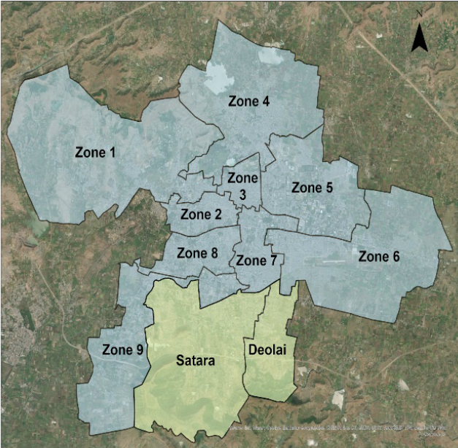
Zones | Area in Sq.km
ZONE 1 | 39.44
ZONE 2 | 4.3
ZONE 3 | 2.67
ZONE 4 | 24.91
ZONE 5 | 24.19
ZONE 6 | 17.7
ZONE 7 | 6.49
ZONE 8 | 53.53
ZONE 9 | 6.14
Total Area | 179.37

Of all the 9 administrative zones in the municipal limit, Zone 2, 3, 7 and 8 are densely populated zones compared to others. The old city and major commercial activity take place in these zones, resulting in high daytime population density. This attracts major traffic during the day. Higher traffic volumes during peak hours and need for parking, leads to major traffic congestion. Mobility corridors like Jalna Road, Railway Station Road and Bus Stand Road also experience high level of traffic and on street Parking. The average travel distance in Aurangabad city is approximately 5 km.

Population data

Year | District Population  data | City Population  data | CAGR %  (City) | CAGR %  (District)
1991 | 22,13,779 | 5,73,272
2001 | 28,97,013 | 8,73,311 | 4 | 3
2011 | 37,01,282 | 11,75,116 | 3 | 2

Reference- Census of India, 2011

The rate of growth of 4% between 1991 to 2001 and 3% between 2001 and 2011 is based population census data.

Aurangabad city data- Vehicle population and projection.

Aurangabad City – CAGR of 2 wheelers, 4 wheelers
Year | 2W Nos | CAGR% | 4W Nos | CAGR % | population | CAGR %
2011 | 1,93,878 |  | 19,662 |  | 11,75,116 | 3
2021 | 6,66,721 | 13 | 72,635 | 14 | 15,51,153 | 2.8

Reference - RTO Aurangabad, Road Transport year book (2009-2011), MoRTH, India

Vehicle density

Vehicle density is number of vehicles per km of road length. Aurangabad approximately has total road length of 1365 km and 7.4 lakhs total number of personal motor vehicles in year 2021.

Comparative analysis of population and Vehicle density

City | No of Personal Vehicles  ( Mn) | Road length (Km) | Vehicle density ( per km of road)
Mumbai | 2 | 2000 | 1014
Delhi | 7.3 | 30000 | 245
Kolkata | 0.5 | 1400 | 355
Chennai | 3.7 | 1800 | 2055
Pune | 2.26 | 1800 | 1260
Hyderabad | 3.4 | 4700 | 723
Aurangabad - 2021 | 7.4 | 1365 | 542

Reference:https://timesofindia.indiatimes.com/city/mumbai/mumbai-indias-most-car-congested- city/articleshow/68554703.cms

If we compare vehicle density of Aurangabad city with other Indian cities then it is observed that in current scenario Aurangabad has lesser vehicle density, except city of Delhi and Kolkata! In spite of lower vehicle density due to extensive road network, Delhi experiences very high levels of congestion and pollution.

It is important to note that even though population growth rates have reduced to 3% and lower, the population density is going to grow high and vehicle density significantly higher making the city very crowded.

Vehicle ownership

Aurangabad City – Vehicle ownership%
Year | 4W /100 | 2W/100
2011 | 2 | 16
2021 | 5 | 43

The above data analysis shows, the growth of vehicle percentage that is vehicle per 100 population in the coming decades. According to the above analysis in 2021 itself the ownership of 4 wheelers is projected to be 5% of the population that means 50 cars per 1000 persons and the ownership of two wheelers is 43% of the population that means 430 two wheelers per 1000 persons.

Equivalent car space unit (ECS)

The space required to park one car is equivalent car space unit (ECS). The car parking slot size is 5 x 2.5 mt that is 12.5 sqm. Similarly, various types of vehicles require different slot size. The space required for other vehicles is converted to ECS to create a unit for planning parking spaces.

It is important to understand that for car to reach the parking slot it requires circulation space. This circulation spaces varies from the nature of parking facility.

If car is parked on the street parallel to the footpath, it shall require minimum of 15 -20 sqm of parking space, also if it is larger size car, it shall require more space. Following table shows the gross area required which includes circulation space for various type of parking per ECS.

Parking space requirement

Vehicle type | Parking slot size.  (L X W) | Parking space  requirement (sq. m) | ECS
Car | 5 x 2.5 | 20-36 | 1
2-wheeler | 2 x 1 | 4 - 8 | 0.2
Auto rickshaw | 2.5 x 2 | 10-15 | 0.5
Bus | 10 x 3 | 55-60 | 2.5
LCV | 5 x 2.5 | 20-36 | 1
HCV | 7.5 x 3.75 | 55-60 | 2.5
Emergency  vehicles |  | 55-60 | 2.5
Bicycle | 2 x 0.6 | 2-3 | 0.1
Reference - Guidelines for parking facilities in urban areas irc.gov.in.sp.012.2015.pdf

Parking space requirement for type of car parking facility

Sr.No | Type of car parking | ECS (area in sq.mt)
1 | On street parallel | 15
2 | Off street open | 23
3 | Ground floor covered | 28
4 | Basement | 32
5 | Multi-level with ramps | 30
6 | Auto mated multi-level with lifts | 16

Reference- MPD- 2021- Delhi Masterplan 2021

Cost investment for building off street car parking facility

Type of off-street parking | Area in sqm | Cost of construction In  Lakhs /ECS ( 2015)
Conventional parking  (Multilevel) | 32 | 4- 6
Stack parking | 16 | 1.5
Fully automated |  | 8 - 10

Reference - Guidelines for parking facilities in urban areas irc.gov.in.sp.012.2015.pdf

C. Case Studies Case study 1
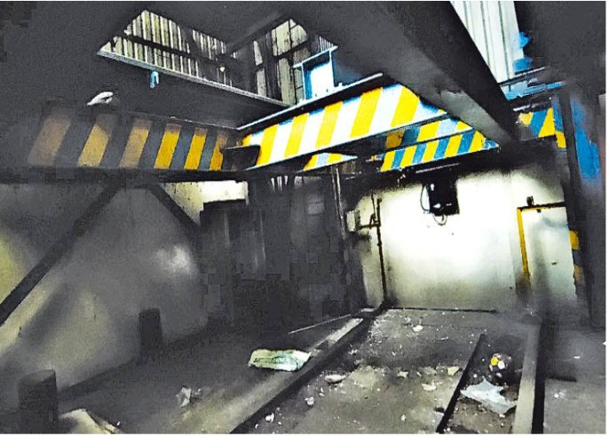
A case study of Pune Multilevel parking facility near JM road, published in Pune mirror in Aug 2021 states that, Municipal corporation due to very high level of congestion and parking demand on Janli Maharaj Road, constructed multi-level parking on BOT system for 100 car parks @ Rs 10 cr in 2017. The operators were collecting parking fees of Rs 5 per hr.

In spite of charging low fees, they were not able to attract people to use the
parking lot, as the on-street parking in the surrounding area was available free of cost. Unfortunately, as per the report, this parking facility is a junkyard, taken up by miscreants.

Reference- https://punemirror.com/pune/civic/vital-parking-lot-or-dream-for-looters/cid5083976.htm

Case study 2

Many such public multilevel parking have been constructed by builders in Mumbai city and are handed over to Municipal Corporation of Greater Mumbai. It was observed that occupancy of such off parking was less than 20%, as people found facility less accessible.

“No parking zone” up to 500 m around the off-street parking facility with fines up to Rs10,000, helped to increase occupancy to some extent, but such measures if not supported with regular and adequate compliance measures cannot sustain for long.
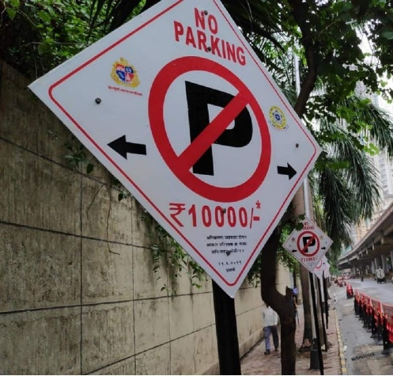
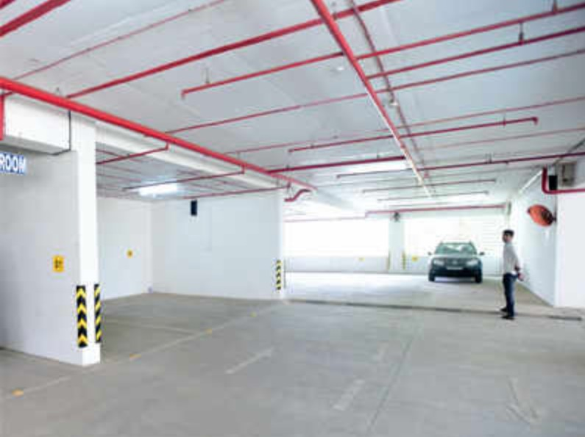

Mumbai with very high population, vehicle density and very high level of traffic congestion and high parking demand, is finding is difficult to achieve optimum utilization of available off-street parking and increase their turn over then it is definitely going to be very challenging for other cities in India with lesser traffic density. Cities like Delhi, Bangalore have also similar issues of low occupancy due to freely available on street parking. (Refer Bangalore policy 2.0, Page 2)

D. Surveys for Area Parking Plan (APP)

The following process should be followed while preparing the Area Parking Plans to ensure consistency across the various zones:

- To prepare APP, delineate area and streets with both high and low demand for parking

- APP cannot be of only individual street or parking lot.

- Undertake survey of existing peak hour parking inventory (on-street and off-street) in the Zone. (Refer Table A, B, C)

- Assess the extent of parking saturation in the Zone during morning and evening peak hours which includes, on-street, off-street parking during weekdays and weekends, long term parking in mixed land use areas and night parking in residential areas.

- Task force to evaluate possibility of providing parking on narrow street with high traffic volume, analyse road carrying capacity/traffic density for both vehicles and pedestrians, based on IRC standards during peak and non-peak hours.

- Identify suitable on-street and off-street (only if needed) locations to meet the likely parking demand in the area.

- The APP shall define “No parking” based on the road width, traffic volumes, traffic junctions, abutting land use entry exits, alighting boarding for public transport/Auto Rickshaws stand and other uses and other emergency services.

- On street parking shall be provided only after finalising “No parking” areas.

- Parking space for bicycles, disabled must be reserved in each zone as per requirements.

- The parking capacity of the parking zone shall be defined in equivalent car space unit that is ECS.

Table A – Parking Inventory: Morning Peak

Parking Inventory- (Name of Area - Size in sq. km )
DD/MM/YY
Morning peak ( 00:00 TO 00.00 AM)
Road name | Street (Left  +right) | 2W | 4W | Taxi | Rickshaw | bus | bicycle | LCV/HCV | Total
 | street 1
 | street 2
 | street 3
 | street 4
 | street 5
 | street 6
 | TOTAL  Inventory | A | B | C | D | E | F | G
 | Total  ECS | A x  0.2 | B x 1 | C x 1 | D x 0.5 | E x  2.5 | F x 0.1 | G x 2.5

Table B – Parking Inventory: Evening Peak

Parking Inventory- (Name of Area - Size in sq. km )
DD/MM/YY
Evening peak ( 00:00 TO 00.00 AM)
Road name | Street (Left  +right) | 2W | 4W | Taxi | Rickshaw | bus | bicycle | LCV/HCV | Total
 | street 1
 | street 2
 | street 3
 | street 4
 | street 5
 | street 6
 | TOTAL  Inventory | A | B | C | D | E | F | G
 | Total  ECS | A x  0.2 | B x 1 | C x 1 | D x 0.5 | E x  2.5 | F x 0.1 | G x 2.5

Reference for determining ECS - Guidelines for parking facilities in urban areas irc.gov.in.sp.012.2015.pdf

Table C – Parking Inventory: Night

Parking Inventory- (Name of Area - Size in sqkm )
DD/MM/YY
Night (post 10 pm) (00:00 TO 00.00 AM)
Road name | Street ( Left + right). | 4w
 | street 1
 | street 2
 | street 3
 | street 4
 | street 5
 | street 6
 | TOTAL Inventory = Total ECS

Table D – Determining “No Parking” Road Length

ROW  mt | Name of the street | Parking side | "No Parking" road length (m)= B
 |  |  | Entry on left | Entry on Right | Main Jn nos x ---  mt | Int Jn nos x --  -mt | Bus stop x---mt | Other x -- mt | Total=B
 | Street 1 | Both Side
 | Street 2 | Both Side
 | Street 3 | One side
 | Street 4 | Both Side
 | Street 5 | One side
 | Street 6 | One side
 | Total

Table E – Determining Available Road Length for Parking

Name of the street | Existing road curb length (m) =A |  |  | "No Parking" road length (m)=B | Available parking length  (m) (A-B) =C
 | Left Side ( less cross  rd width) (l) | Right Side (less cross rd width) (r) | Total (l + r) =A
Street 1
Street 2
Street 3
Street 4
Street 5
Street 6
Total

Table F - Determining existing parking saturation for parking demand

Name of the street | Existing road curb length (m) =A
 | Available Road length for Parking (C) | Maximum possible ECS @ 6 m road length  per ECS (C/6 = E) | Actual ECS based on Peak hour inventory (F) | Existing Saturation  /demand (F/E %)
Street 1
Street 2
Street 3
Street 4
Street 5
Street 6
Total

Note: Determining saturation/demand will help identify streets having saturation above 60% which can be considered for pay & park lots

E.Pilot Studies based on APP Survey

- Connaught area - Mixed Use Neighbourhood

Connaught Area is one of the popular mixed use neighbourhoods of the city of Aurangabad. Planned as a part of town centre within CIDCO’s New Aurangabad, it has become a popular destination amongst the youth of the city for socializing. Lined with mobile/gadgets shops and eateries/restaurants and street food vendors, Connaught Area is at its busiest in the evenings. At the heart of the neighbourhood is the Connaught Garden that is lined with shops on all sides, thus making the garden almost invisible to the street users.

Following issues are observed on the streets of:

  - Wide ROW (21m) allows for haphazard parking.

  - Undermaintained footpaths remain unused by pedestrians

  - Double and Triple parking across the road reduces travel lane, causing congestion

  - Speeding vehicles, honking and congestions are a common sight

  - Street food vendors located at junction attract haphazard parking at junction

  - Lack of enforcement leading to unorganized parking

  - Presence of multiple Parking signages leading to confusion

  - Footpaths are encroached up by shopkeepers and hawkers making the pedestrians use the travel lane for walking.

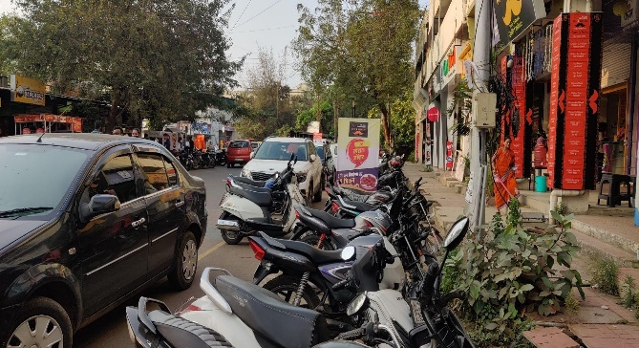
Image 1: Double line parking of Two Wheelers and Cars

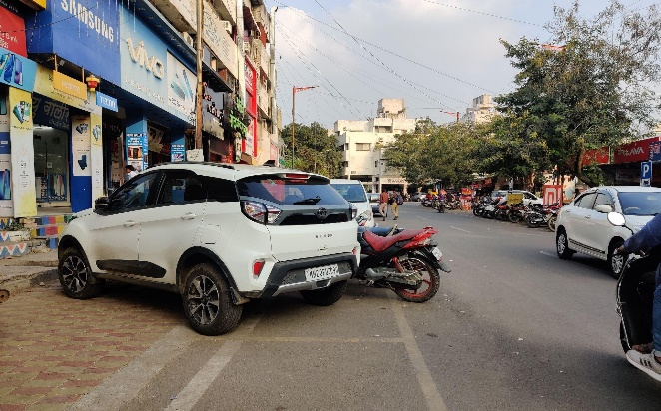

Image 2: Unorganized, haphazard Parking
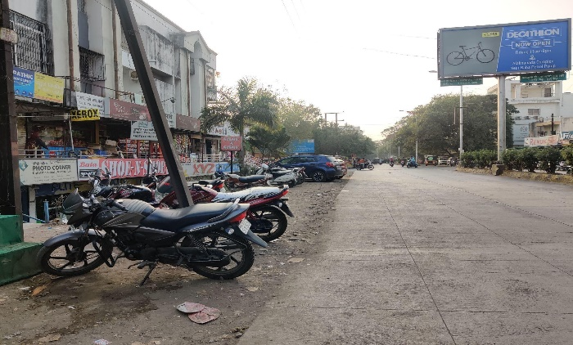
Image 3: Lack of footpath, Parking upto property line
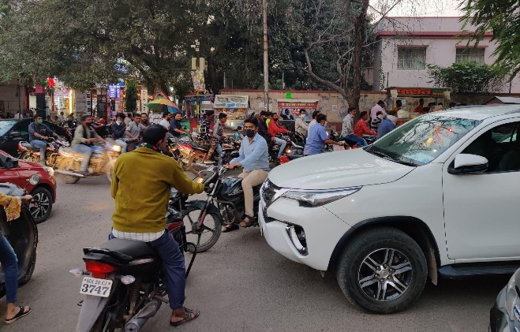

Image 4: Traffic congestion at junctions and turnings
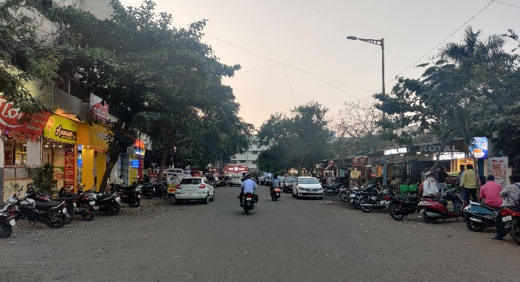
Image 5: Underutilized Carriageway leading to wastage of valuable road space

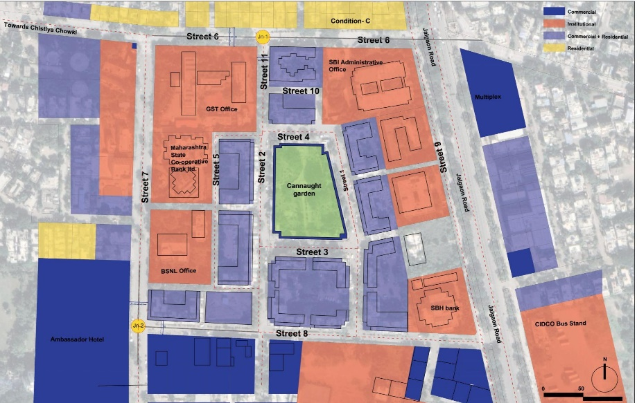
Image 6: Land Use Plan

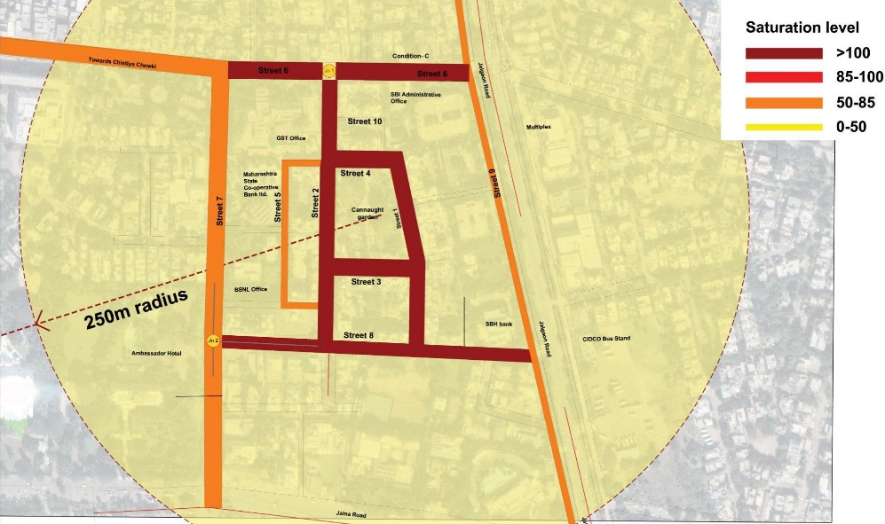
Image 7: Parking Saturation/demand

Pilot site | Connaught
Total road Kerb length available for parking | 5600mts
Peak hour ECS | 853
Required road kerb length for parking @6m/ECS | 5118 mts

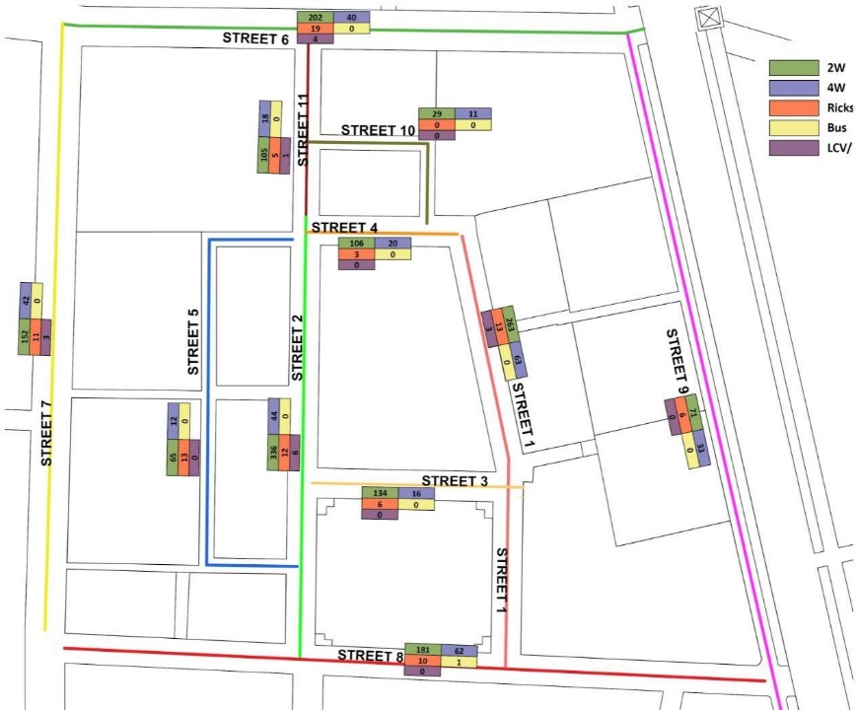

Image 8: Parking Distribution

USMANPURA - KRANTI CHOWK

The study area spans from Kranti Chowk to Amarpreet Hotel, Kalda Corner to Guru Tegh Bahadur Chowk, covering neighbourhoods such as Shreyanagar, Zambad estate and part of Jyotinagar. The study area is approximately 0.65 sq km. The study area comprises predominantly Residential land Use. Major Commercial streets are Kranti Chowk - Guru Tegh Bahadur Road, Gopal T - Utsav and some adjoining lanes. Kranti Chowk is one of the busiest and critical junctions of the city. Major parking demand generating activities in the site are the coaching classes, retail, banks, hospitals and office buildings. Being one of the older residential areas of the city, cars are often seen parked on residential streets in areas such as Zambad estate, Shreynagar and Jyoti Nagar.

Following issues are observed on the streets of Usmanpura - Kranti Chowk Study area:

  - Parking till property line

  - Heavy encroachment on both sides of road

  - Congestion on carriageway due to haphazard parking

  - Lack of demarcated on-street parking spaces

  - Lack of Property boundary on road side - utilizing setbacks as parking

  - At grade footpath being used as Parking

  - Encroached footpath by vehicles and vendors

  - Underutilized and under-maintained footpaths

  - Absent or non-continuous footpaths

  - On street parking on residential streets

  - Existing off-Street parking (basement) unused

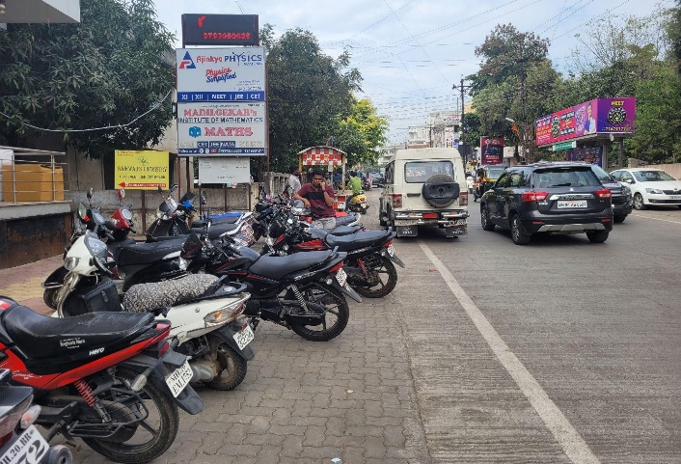

Image 9: Flushed footpath surface being used for Parking
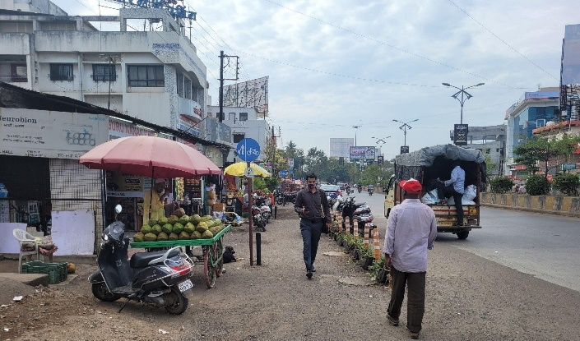

Image 10: NMT lane being used for parking, lack of on street-parking demarcation
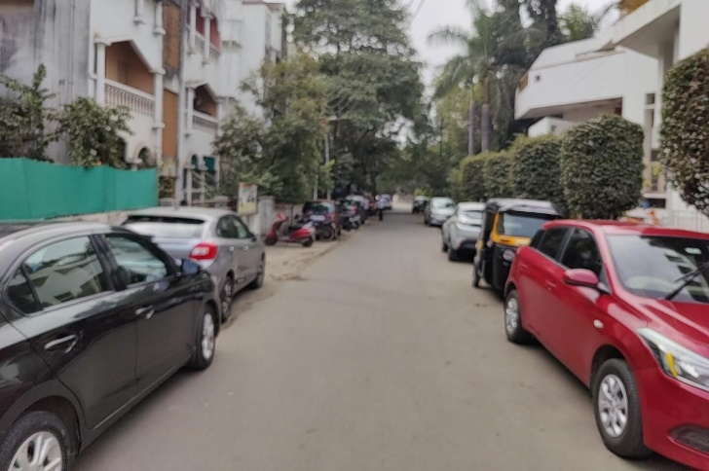
Image 11: Residential Streets lined with Car Parking

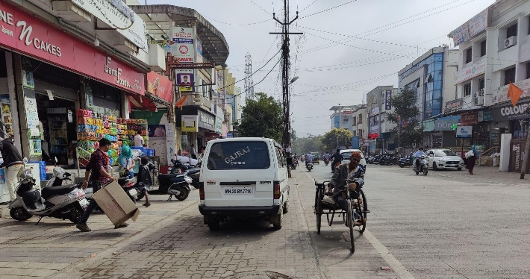

Image 12: Newly constructed road - At grade footpath facilitating parking upto property line.
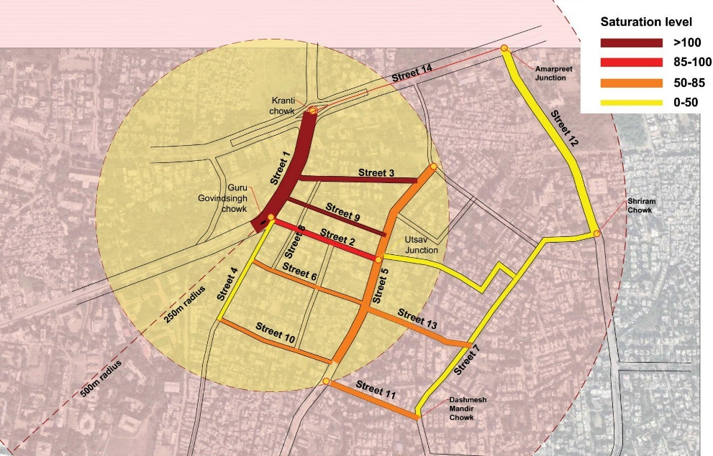
Image 13: Parking Saturation/demand

Pilot site | Usmanpura - kranti  chowk
Total road Kerb length available for parking | 12000 mts
Peak hour ECS | 972
Required road kerb length for parking @6m/ECS | 5832 mts

TV CENTRE

This study area is a part of CIDCO-planned New Aurangabad. Largely comprising high density LIG/MIG residential sectors, this area also has some large parks and public institutions. The main street from Jalgaon Road to TV center is a thriving commercial street catering to everyday needs of the locality. It is lined with coaching centers, retail shops, banks, and restaurants. A vegetable market located next to TV center Chowk attracts crowds from nearby localities. The residential area is characterized by narrow lanes (4.5m
- 6m wide), and vertical encroachment. Originally planned to be G+1 development, G+3 structures are a common site in the residential neighborhoods. The predominant land use except the market streets is residential.

Following are the predominant issues:

  - Unorganized Parking up to property line

  - Mismanaged ROW of 30m

  - Vendors and Parking encroaching on pedestrian space

  - Lack of demarcated parking spaces

  - Lack of footpath
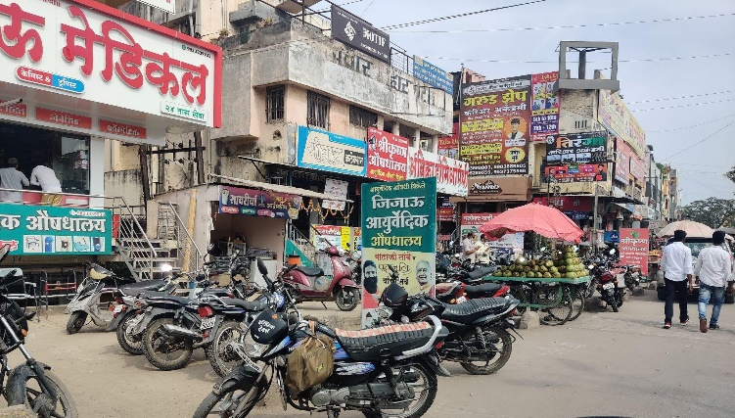

Image 14: 6-8m wide footpath space occupied for parking and vending
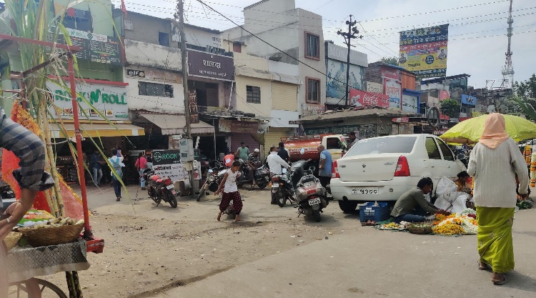

Image 15: Unpaved footpath space pushing pedestrians on carriageway
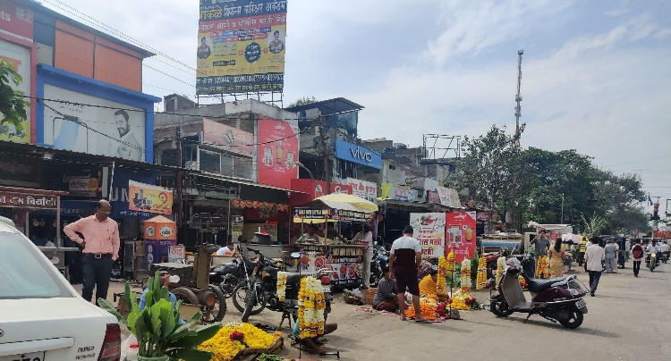

Image 16: Heavy encroachments by retail shops, vendors and parking

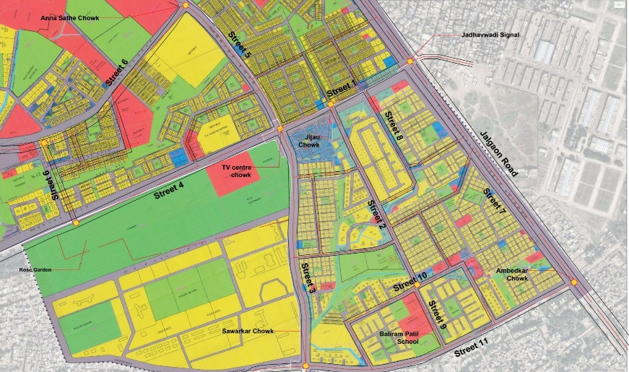

Land Use Plan

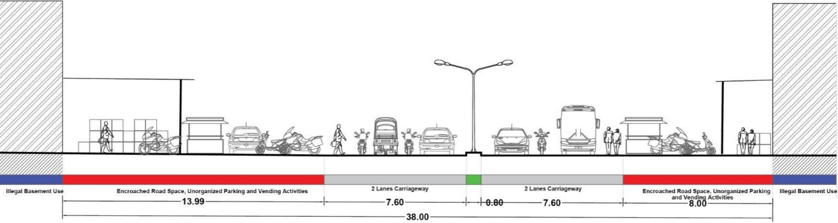
Existing Section : Street 1
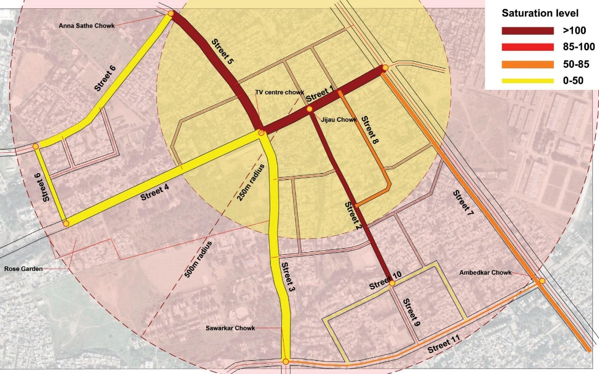

Image 17: Parking Saturation/demand

Pilot site | TV Centre
Total road Kerb length available for parking | 14500 mts
Peak hour ECS | 1297
Required road kerb length for parking @6m/ECS | 7782 mts

NIRALA BAZAAR - AURANGPURA

Located in the close proximity to the old city market area, the study area is one of the older neighbourhoods of the city. A decade down the line, this was the most sought-after destination for retail businesses. It has the city’s oldest educational institutions such as Saraswati Bhuvan School and College and many other schools. It also has private educational centers like coaching classes, libraries and study centers. Other crowd pulling activities include administrative offices, wholesale and retail shops, Multiplex etc.

Following are the predominant issues:

  - Parking till property line

  - Reduced carriageway width due to haphazard parking

  - Parking enforcement issues

  - Encroached footpath by vehicles and vendors

  - Underutilized and under-maintained footpaths

  - Absent or non-continuous footpaths
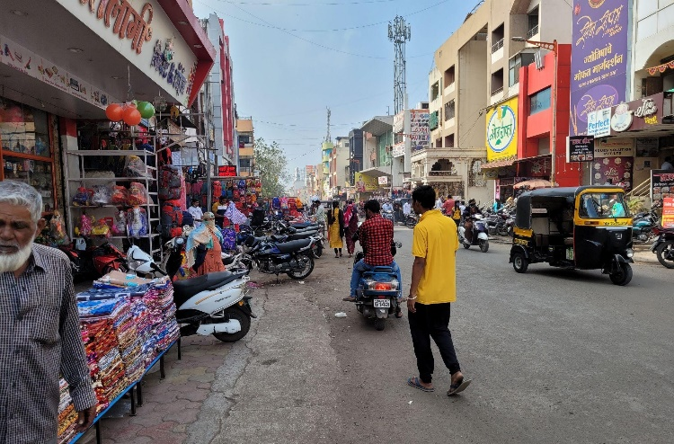
Image 18: Lack of footpaths on market Street, Parking upto shopfront

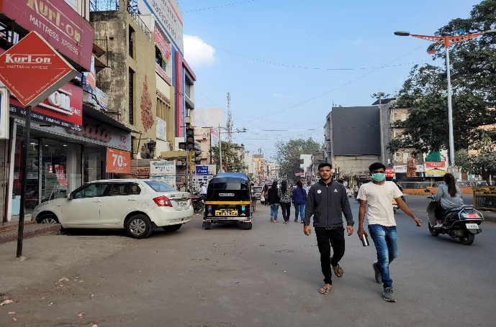

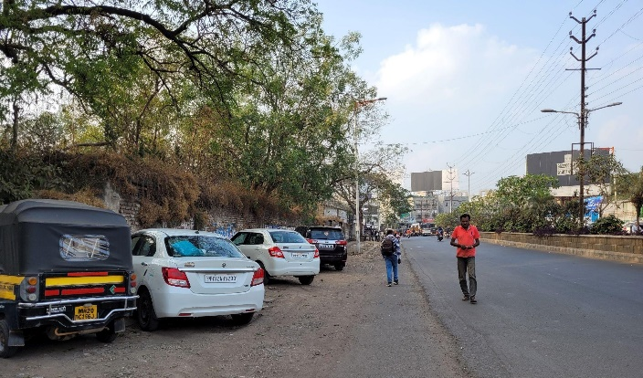
Image 19: Pedestrians pushed to carriageway

Image 20: Unused Road space
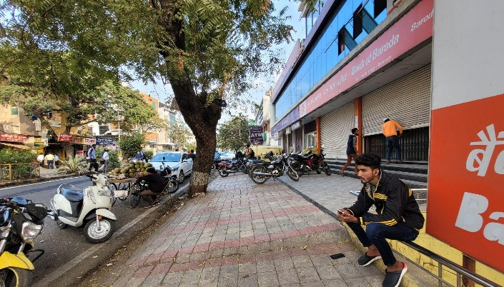

Image 21: Footpath and building setback used for parking

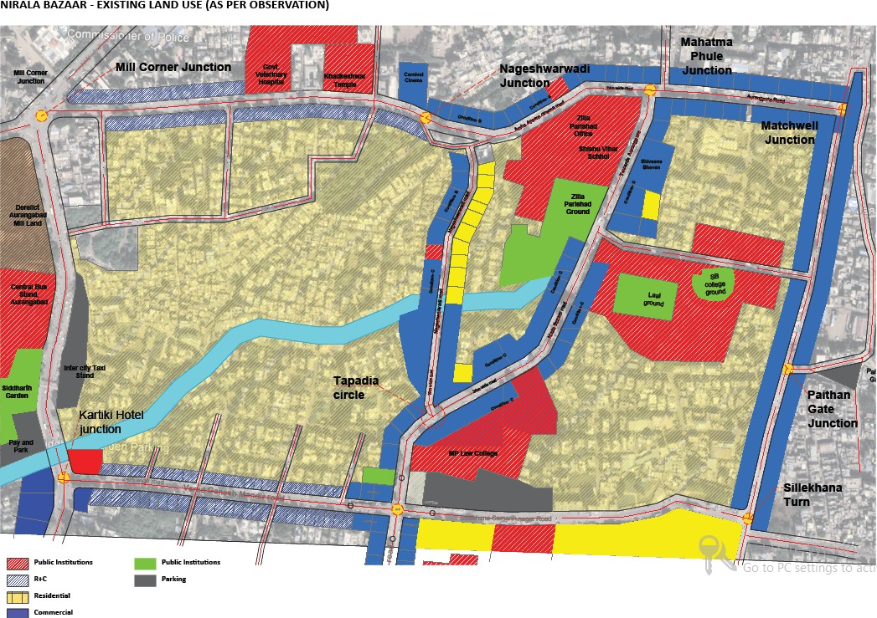

Land Use Plan

Image 22: Parking Saturation/demand

Pilot site | Nirala Bazaar
Total road Kerb length available for parking | 11500mts
Peak hour ECS | 1106
Required road kerb length for parking @6m/ECS | 6636 mts

PUNDLIK NAGAR - GAJANAN MANDIR

The study area spans from Seven Hills flyover to Reliance Mall, covering neighborhoods such as high density LIG area Pundliknagar, Jawahar Colony, Chetak Ghoda to Trimurti Chowk. The major crowd pullers are Gajanan Maharaj Mandir, Hedgewar Hospital, vegetable/fruit/flowers and puja samagri vendors This site sits at the confluence of the major and one of the busiest arterial roads of the city. The commercial character of this site comprises retail shops, hospitals, small eateries, etc. There is a general conflict between the traffic and street vending activity on the commercial streets.

Following are the major problems:

  - Mismanaged pedestrian space

  - Haphazard parking and Street vending

  - Lack of demarcated parking space

  - Lack of paved footpath surface

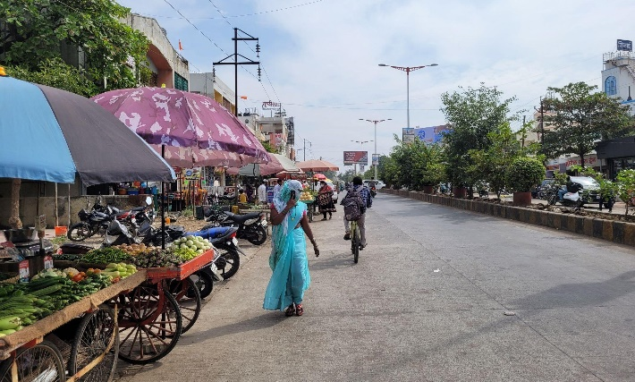

Image 23: Unorganized Parking and Vending encroaching footpath space
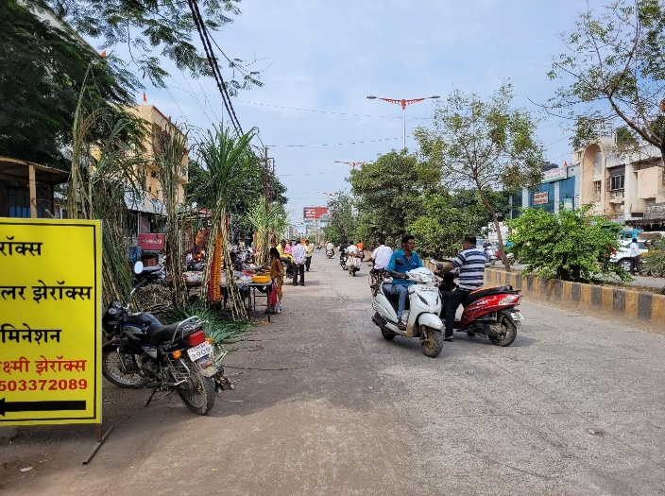
Image 24: Indisciplined parking, traffic and vending activities on street

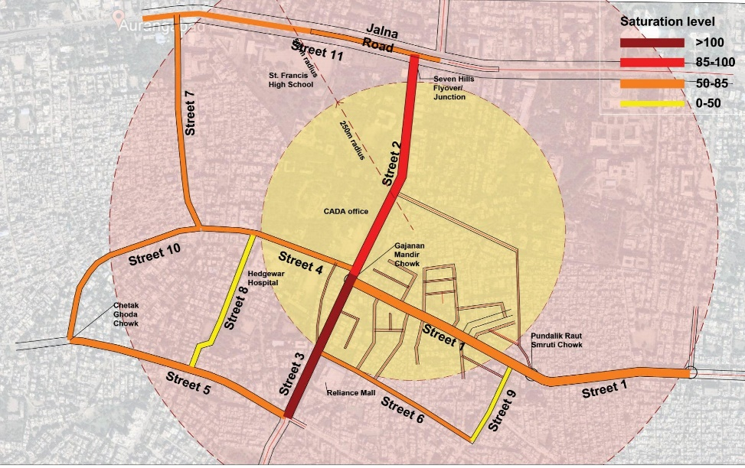
Image 25: Parking Saturation/demand

Pilot site | Pundalik Nagar
Total road Kerb length available for parking | 10500 mts
Peak hour ECS | 986
Required road kerb length for parking @6m/ECS | 5916mts

F.Proposed Parking Fees Proposed Peak hour parking fees
On street parking fee - Peak hours only
 | Morning / Evening peak hour ( 3- 4 hrs each)
Vehicle  Type | <1 hr | 2 hr | 3hr | 4 hr
2-wheeler | 10 | 15 | 20 | 25
Private Car | 30 | 40 | 60 | 80

Proposed Short term parking fees

On street parking fee for short term parking
 | Day (8am-8pm) |  |  |  |  |  |  |  |  |  |  |  | Night (8pm-  8am) | Full day
Vehicle Type | 1  hr | 2hr | 3hr | 4hr | 5hr | 6hr | 7hr | 8hr | 9hr | 10h r | 11h r | 12  hr | <1-12  hr | 24  hr
2-  wheeler | 5 | 5 | 5 | 10 | 10 | 10 | 15 | 15 | 15 | 20 | 20 | 20 | 5 | 25
Private  Car | 15 | 30 | 45 | 60 | 75 | 90 | 105 | 120 | 120 | 120 | 120 | 120 | 10 | 130

Parking fee for Equivalent Car Space shall be based on rental value of the land.( 2% of the ownership value) Assuming annual rental value of Rs 3000 per sqm in a designated pay and park location (3000 x 15 sqm ECS area ) / 3000 parking hour/ year = Rs 15 per hour for 1 ECS.

Proposed Long term parking fees

On-Street parking charges for Long term parking
 | Mixed Land use  Minimum Monthly Parking Charges @ 10 days |  |  | Residential area Parking charges
Vehicle Type | Day 12 hrs (8am-8pm) | Night 12hrs (8pm-8am) | 24 hrs Day + Night | Quarterly | Annually
2-wheeler | 200 | 50 | 250 | 250 | 1000
Private Car | 1200 | 100 | 1300 | 1000 | 4000

G.Revenue projections

Projected Revenue collection from Pay and park:

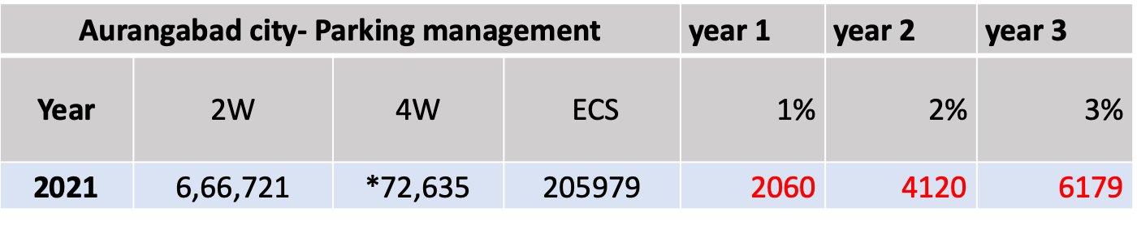
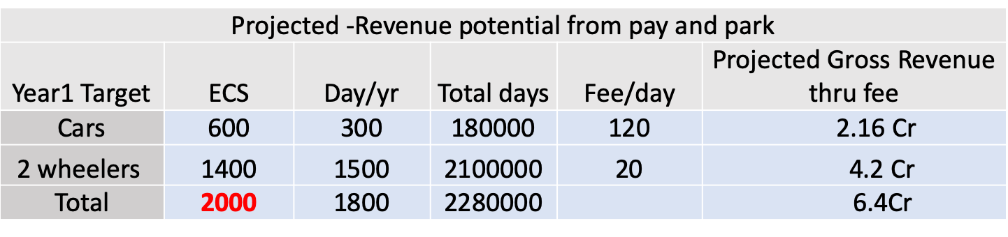
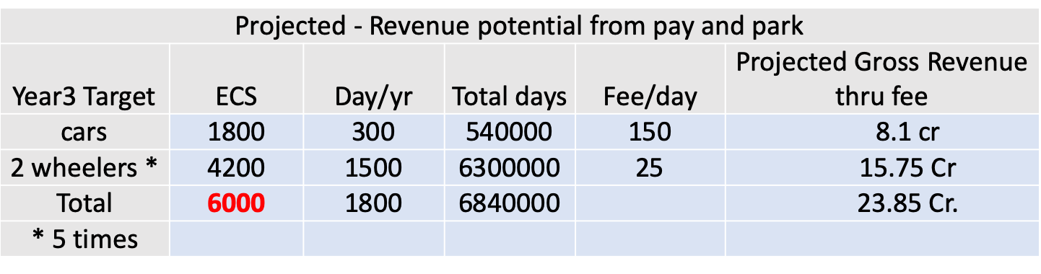

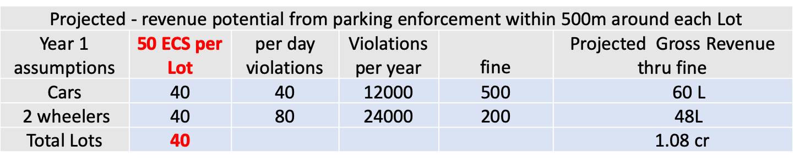
Projected Revenue collection from Pay and park:

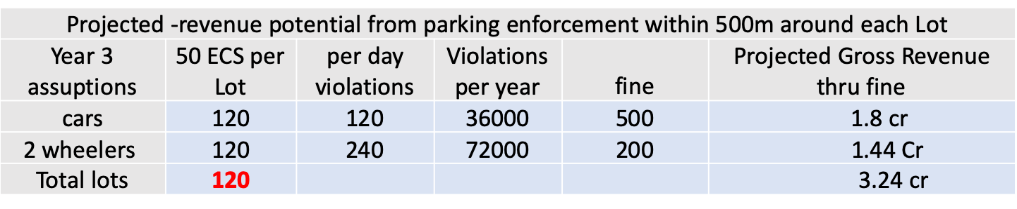

Municipal Commissioner and Administrator,
Aurangabad Municipal Corporation

